A project work done in partial fulfilment of the “Certificate course on Data Analytics & Business Intelligence”

Data Analytics & Business Intelligence


Submitted by:
Daksh Bhatnagar

Certificate Course on Data Analytics & Business Intelligence Batch-11

Shaheed Sukhdev College of Business Studies

November, 2024

ACKNOWLEDGEMENT

I would like to express my special thanks of gratitude to Mr. Rishi Rajan Sahay who gave me the opportunity to do this wonderful research project on the topic “Analysis and Prediction of Breast Cancer” which helped me in doing a lot Research and I came to know about so many new things. I wish to thank my parents as well for their undivided support that encouraged me, without which I would not be unable to complete my project.

DECLARATION

I, Daksh Bhatnagar , hereby declare that the project titled
"Analysis and Prediction of Breast Cancer" is a result of
original research work carried out under the guidance and supervision of Dr.
Rishi Ranjan Sahay, Assistant Professor at Shaheed Sukhdev College of
Business Studies, University of Delhi.
This project work is undertaken as part of certificate course in Data
Analytics and Business Intelligence and is submitted in partial fulfilment of the
requirements for the award of the certificate of Data Analytics and Business
Intelligence at Shaheed Sukhdev College of Business Studies, University of
Delhi.

I affirm that the research and findings presented in this project are genuine. All
sources of information and data have been acknowledged appropriately.
I also declare that any help received in carrying out this project and preparing
the report has been duly acknowledged.

Abstract

Breast cancer remains one of the leading causes of mortality among women worldwide. Early detection of this disease significantly increases the chances of successful treatment and survival. Predictive machine learning models can provide valuable insights by analyzing medical data to classify and predict breast cancer diagnoses. In this project, a variety of machine learning algorithms, including Logistic Regression, Decision Tree Classifier, Random Forest Classifier, K-Nearest Neighbors, Naive Bayes, and Support Vector Machine, are applied to a breast cancer dataset. The objective is to build an accurate and robust model for predicting breast cancer using features extracted from digitized mammography images. By utilizing various evaluation metrics such as accuracy, precision, recall, and F1-score, the models are compared and tuned for optimal performance. The Random Forest model emerges as the most promising due to its high accuracy and robustness against overfitting.
The results tell us about importance of machine learning in the Medical field.

Introduction

Breast cancer is one of the most common cancers affecting women globally, with millions of new cases diagnosed each year. Timely and accurate diagnosis plays a crucial role in the effective management and treatment of the disease.
Traditional diagnostic methods, while effective, can sometimes lead to delayed detection or misclassification, especially in cases of subtle abnormalities. As a result, leveraging advanced technologies such as machine learning (ML) has emerged as a viable solution for enhancing diagnostic accuracy.
Machine learning has shown great promise in predictive modeling across a range of medical applications, including breast cancer diagnosis. These models analyze vast amounts of data, learning patterns that can distinguish between malignant and benign tumors.
This project aims to explore the application of machine learning algorithms to predict breast cancer by analyzing features from a dataset containing attributes of breast tumors. The main focus is on comparing multiple machine learning models, determining the best-performing one, and providing an accurate, efficient, and interpretable tool for breast cancer prediction.



Dataset Preparation and Exploration
The dataset used in this project is sourced from the Wisconsin Breast Cancer Dataset, which contains 569 instances of breast cancer diagnoses. https://data.world/health/breast-cancer-wisconsin

Each instance is described by 30 features that quantify tumor characteristics such as mean radius, texture, perimeter, area, and smoothness. These features are derived from digitized images of fine needle aspirate biopsies. The target variable is the diagnosis, which indicates whether a tumor is malignant or benign.
Before building the model, data cleaning and preprocessing are essential. This includes handling missing values, normalizing the data, and encoding categorical variables such as the diagnosis labels (Malignant/Benign). Exploratory data analysis (EDA) is performed to understand the relationships between the features and the target variable. Visualization techniques such as heatmaps and pair plots help identify correlations and patterns in the dataset.
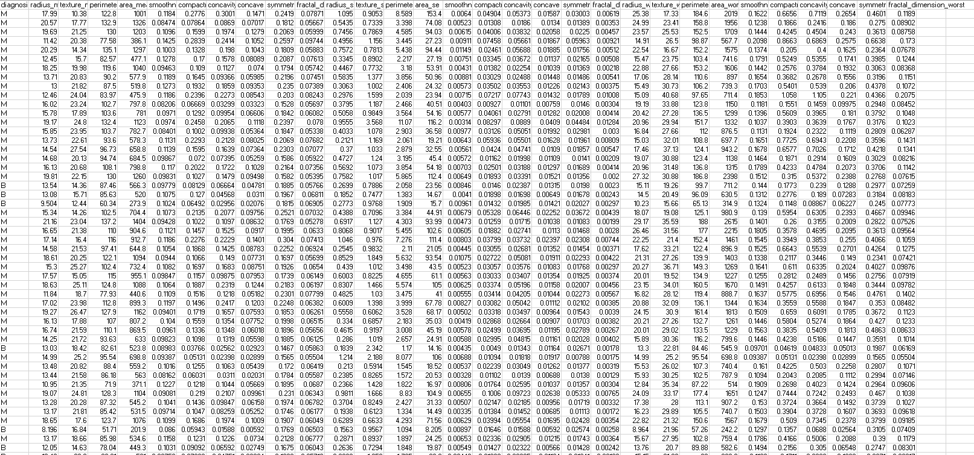

Feature Engineering
Feature selection plays a crucial role in reducing model complexity and improving accuracy. By removing redundant or irrelevant features, we can enhance the model’s performance. In this project, a correlation matrix is used to identify highly correlated features. Additionally, recursive feature elimination (RFE) and other feature selection techniques are explored to further refine the input data.
Model Selection
Several machine learning algorithms are implemented to build predictive models:
- Logistic Regression: A simple yet effective linear model used for binary classification.
- Decision Tree Classifier: A non-parametric model that splits data based on feature values, making decisions in a hierarchical structure.
- Random Forest Classifier: An ensemble of decision trees that improves generalization and reduces overfitting by averaging multiple tree outputs.
- K-Nearest Neighbors (KNN): An instance-based learning algorithm that classifies data points based on the majority class of their neighbors.
- Naive Bayes: A probabilistic classifier that assumes independence between features.
- Support Vector Machine (SVM): A powerful classifier that finds the optimal hyperplane to separate classes in a high-dimensional space.
Each of these models is trained and tested on the dataset using a train-test split. Hyperparameter tuning is performed to optimize the performance of each model. Techniques such as cross-validation are used to ensure that the models generalize well to unseen data.

Model Evaluation
To assess the performance of the models, several evaluation metrics are used, including:
- Accuracy: The proportion of correctly classified instances. = 0.9095744680851063
- Precision: The number of true positive predictions divided by the total number of positive predictions. = 0.01
- Recall (Sensitivity): The number of true positive predictions divided by the total number of actual positives.= 1
- F1-Score: The harmonic mean of precision and recall, providing a balanced measure of a model's performance.= 0.01980198019802
- Confusion Matrix: A table that summarizes the classification performance by showing true positives, true negatives, false positives, and false negatives. 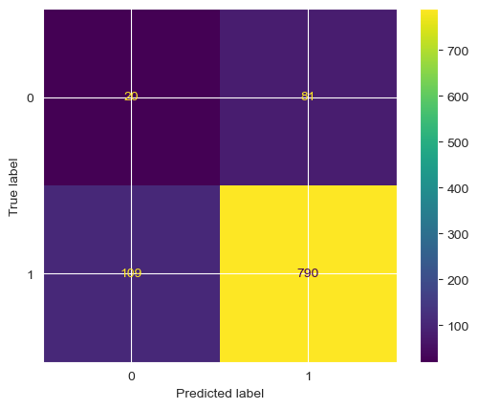

These metrics help determine which model best fits the dataset and offers the most accurate predictions. Additionally, the models' learning curves and ROC (Receiver Operating Characteristic) curves are analyzed to evaluate their performance under different thresholds and ensure robustness.

Model Interpretation and Feature Importance
Interpretable machine learning is crucial in medical applications, as doctors need to understand the reasoning behind a model's prediction. In this project, techniques such as feature importance from the Random Forest and coefficients from the Logistic Regression model are used to interpret the models’ behavior. These methods help identify which features are most influential in determining a diagnosis, providing valuable insights for clinicians.
Feature Importance:
Feature Weights/Importance: Look at the contribution of each feature (e.g., tumor size, radius, texture) towards making predictions. Some models like Random Forest and Logistic Regression provide a way to see which features were most important for the classification.
SHAP Values: Shapley values are a method to explain individual predictions, showing how much each feature contributed to the final decision.
Model Behavior:
ROC Curve (Receiver Operating Characteristic): Shows the trade-off between sensitivity (recall) and specificity. A model with an area under the ROC curve (AUC) close to 1 is considered highly effective.
Thresholds: In binary classification, adjusting the threshold can change the sensitivity/specificity trade-off. It’s important to interpret this in the context of diagnostic tasks where false positives and negatives have different implications.
Cross-validation and Generalizability:
Cross-Validation Results: To ensure that the model performs well on unseen data, cross-validation is essential. This also provides an understanding of how consistent the model is across different subsets of the data.
Overfitting: It's crucial to check whether the model is overfitting (i.e., performing well on training data but poorly on test data) by comparing performance metrics on training vs. test datasets.

Conclusion
This project demonstrates the potential of machine learning in improving breast cancer diagnostics. By applying a variety of classification algorithms, we were able to compare their performances and identify the best-performing model. The Random Forest Classifier, with its ability to handle complex relationships between features and avoid overfitting, emerged as the most promising model for breast cancer prediction in this dataset.
The results from this project highlight the importance of using predictive modeling for early detection of breast cancer, which can lead to better patient outcomes. Machine learning models like the ones explored here can complement existing diagnostic tools, offering a faster and more reliable second opinion. However, it is important to note that while machine learning can significantly aid in prediction, human expertise remains essential in interpreting results and making final clinical decisions.

Bibliography
- https://pmc.ncbi.nlm.nih.gov/articles/PMC9175124/
- https://www.mayoclinic.org/diseases-conditions/breast-cancer/symptoms-causes/syc-20352470
- https://www.kaggle.com/

